Curriculum Vitae

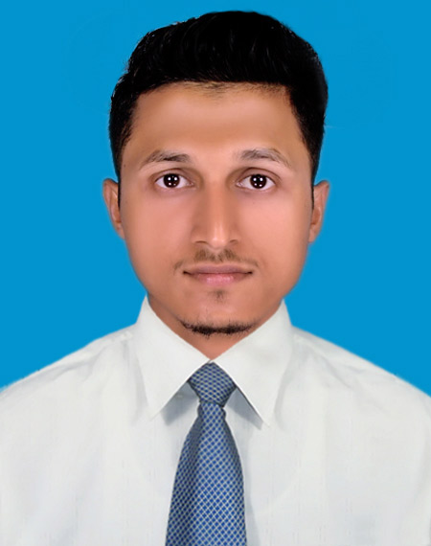

Photo

Of

**Md. Kamrul Islam (Rifat)**

**393, Phathantooly, Chowmuhony**

**Agrabad, ctg.**

**Mobile: +8801830663900¸E-mail: ibnanifti@gmail.com**

**Career Objective:**

To utilize the full inner strengths as well as the concrete academic background to boost the for reaching into the peak of career success and fulfilling the desired vision.

**Career Vision:** To become a top class knowledgeable professional with a sound expertise.

**Communication Skills & Competences:**

***First Language:*** Bengali with an excellent command over reading, writing, listening and speaking.

***Second Language:*** English with an excellent command over reading, writing, listening and speaking.

**Behavioral Strengths & Competences:**

Honest, Punctual, Sharp, Dynamic, Smart, Energetic, Self-motivated & Self-driven,

Confident, Enthusiastic, Positive attitude, unstructured decision-making power.

|  |  |  |
| --- | --- | --- |
| **COMPUTER LITERACY** | Major courses on computer & OFFICE MANAGEMENT completed From “**ANANDA MULTIMEDIA”** | **Operating Systems:** Windows-7, **Applications:** MS Word, MS Excel, MS Access, Power Point and Internet Basics. |

**Core Commitment:**

An exceptional promise and aptitude to face the challenges through hard working and

Contributing to the country in promoting service through the organization.

Educational Qualification (academically achieved):

|  |  |  |  |  |
| --- | --- | --- | --- | --- |
| **ACADEMIC QUALIFICATION** | **Name of Degree** | **Board/ University** | **Year of Examination & Major** | **GPA/CGPA** |
| MBA | USTC | Appeared  (Major: Finance) |  |
|  |  |  |  |
| BBA | University of  Science & Technology Chittagong (USTC) | (Major: Finance) | 3.72  (Scale 4) |
| H. S. C. | Chittagong Govt. City College  (Chittagong Board) | 2013  (Business Studies) | GPA: 4.70  (Scale 5) |
| S. S. C. | Khawja Ajmeri High School  (Chittagong Board) | 2011  (Business Studies) | GPA: 4.81  (Scale 5) |

|  |  |  |
| --- | --- | --- |
| **Achievement** | **BEST PRESENTER** | Outward in **US Embassy, Chittagong Zone Of 2017** |

**Listed Member of Active Gratitude:**

**“Vice –President” of FBA Business Club, USTC**

**“Councilor” of IELTS program**

**“Senior Member” of Rangdhonu Foundation.**

**“Managerial Instructor at AR Tours & Travels**

**Experience:**

* “ Former Intern” at SOUTHEAST BANK LIMITED, BOROPOL BRANCH , CTG.
* Tr. Business Executive ( Lanka Bangla Finance Ltd ) – contrinuing

|  |  |  |
| --- | --- | --- |
| **PERSONAL**  **PRECISE** | Full Name | MD. KAMRUL ISLAM |
| Father's Name | MD. MONJURUL ISLAM |
| Mother's Name | MRS. MOHSENA BEGUM |
| Permanent Address | AS ABOVE |
| Date of Birth | 23rd October 1995 |
| Nationality | BANGLADESHI |
| Marital Status | SINGLE |
| Religion | ISLAM |
| Blood Group | B+ve |
| Country of Origin & Citizenship | Bangladesh |
| Family Title as Surname | ***Rifat*** |

**Declaration**

I do hereby declare that the particulars provided are completely true and no false information is given.

Reference

**Md. Zia Uddin Chowdhury**

Senior Manager Operation

Lanka Bangla Securities Ltd

CDA Avenue Branch, Chittagong.

Cell: +88 01730322522 **Ayub Md Muhit,**

**IDLC Finance Limited**

Mobile: + 8801700701413

Email: mayub@idlc.com

**Md. Kamrul Islam(12/11/2019)**